LeetCode Program 326
Link :- https://leetcode.com/problems/power-of-three/

Successful Submission 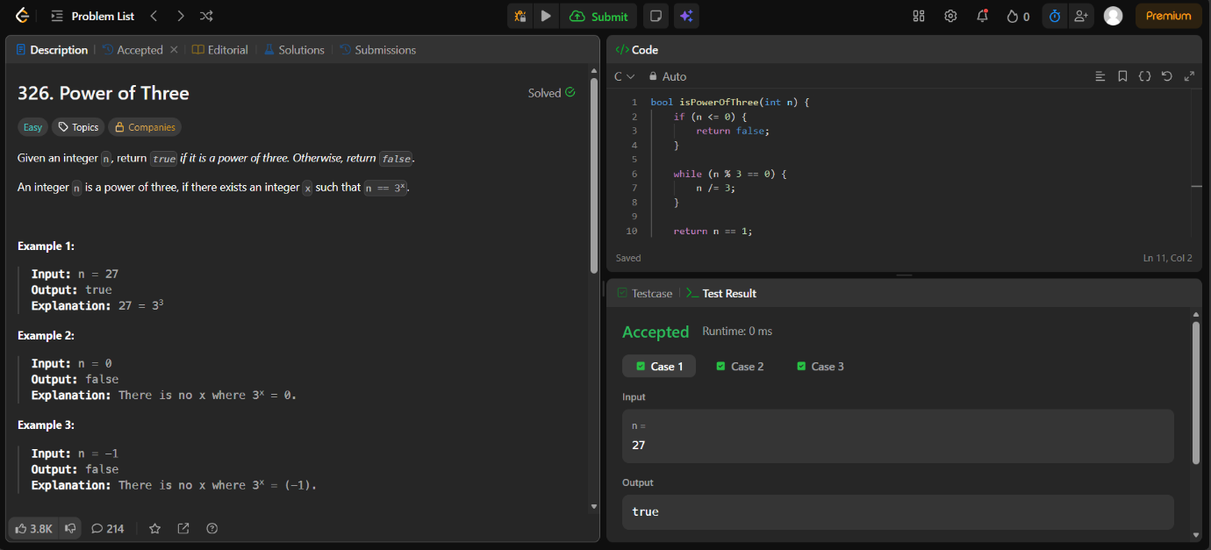
Source Code


